Appendix C

Flight Management System

Process View

Version 1.0

Revision History

|  |  |  |  |
| --- | --- | --- | --- |
| **Date** | **Version** | **Description** | **Author** |
| 01/06/15 | 1.0 | Compilation of Process View | Matthew King  Michael Kong |
|  |  |  |  |
|  |  |  |  |
|  |  |  |  |

Table of Contents

1. Process View 6

1.1 Sequence and Communication Diagrams 6

1.1.1 Add Airport 6

1.1.2 Add Customers 7

1.1.3 Add Flight 9

1.1.4 Add Persons 10

1.1.5 Add Plane 12

1.1.6 Add Route 13

1.1.7 Add Services 15

1.1.8 Book Services 16

1.1.9 Cancel Booking 17

1.1.10 Change Password 18

1.1.11 Choose Seating 19

1.1.12 Close Account 20

1.1.13 Create Staff Profile 21

1.1.14 Delete Airport 23

1.1.15 Delete Flight 24

1.1.16 Delete Plane 25

1.1.17 Delete Route 26

1.1.18 Display Bookings For Month 27

1.1.19 Display Flight History Report 28

1.1.20 Display Monthly Flight Statistics Report 29

1.1.21 Display Monthly Revenue Report 31

1.1.22 Display Top 5 Popular Popular Services Report 32

1.1.23 Edit Account Details 33

1.1.24 Edit Airport 35

1.1.25 Edit Booked Services 38

1.1.26 Edit Flight 39

1.1.27 Edit Plane 41

1.1.28 Edit Route 43

1.1.29 Edit Service Availability 46

1.1.30 Edit Service Price 47

1.1.31 Edit Staff Profile 48

1.1.32 Edit Watch and No Fly List 50

1.1.33 Login 51

1.1.34 Make Booking 52

1.1.35 Manage Airports 55

1.1.36 Manage Fleet 57

1.1.37 Manage Flights 59

1.1.38 Manage Routes 60

1.1.39 Move Passengers 62

1.1.40 Remove Services 63

1.1.41 Set Cancellation Fee 64

1.1.42 Set Discount Ratio 65

1.1.43 Set Ticket Price 66

1.1.44 Signup 67

1.2 Activity Diagrams 70

1.2.1 Add Airport 70

1.2.2 Add Customers 70

1.2.3 Add Flight 71

1.2.4 Add Persons 72

1.2.5 Add Plane 73

1.2.6 Add Route 74

1.2.7 Add Services 75

1.2.8 Book Services 75

1.2.9 Cancel Booking 76

1.2.10 Cancel Customer Booking 77

1.2.11 Change Passenger Seating 78

1.2.12 Change Password 79

1.2.13 Choose Seating 79

1.2.14 Close Account 80

1.2.15 Create Staff Profile 81

1.2.16 Delete Airport 82

1.2.17 Delete Flight 83

1.2.18 Delete Plane 84

1.2.19 Delete Route 85

1.2.20 Edit Account Details 86

1.2.21 Edit Airport 87

1.2.22 Edit Flight 88

1.2.23 Edit Plane 89

1.2.24 Edit Route 90

1.2.25 Edit Service Availability 91

1.2.26 Edit Service Price 92

1.2.27 Edit Services 93

1.2.28 Edit Staff Profile 94

1.2.29 Edit Travel Agency and Customer Profile 95

1.2.30 Edit Watch and No Fly List 96

1.2.31 Generate Report 97

1.2.32 Login 98

1.2.33 Make Booking 99

1.2.34 Manage Airport 100

1.2.35 Manage Fleet 101

1.2.36 Manage Flight Schedule 102

1.2.37 Manage Routes 103

1.2.38 Move Passengers Between Flights 104

1.2.39 Remove Services 105

1.2.40 Set Cancellation Fee 106

1.2.41 Set Frequent Points Discount Ratio 107

1.2.42 Set Ticket Prices 108

1.2.43 Signup 109

# Process View

## Sequence and Communication Diagrams

This section contains all sequence and communication diagrams for the proposed Flight Management System. Each diagram’s title is a brief description of the scenario it depicts.

### Add Airport

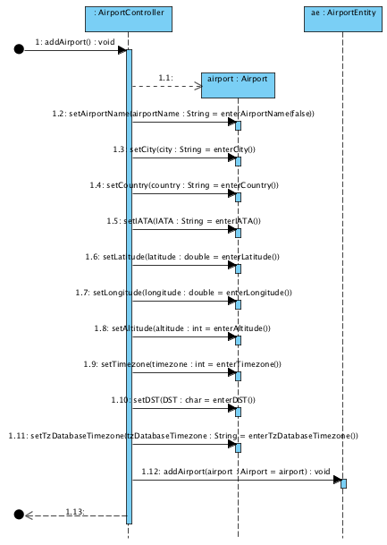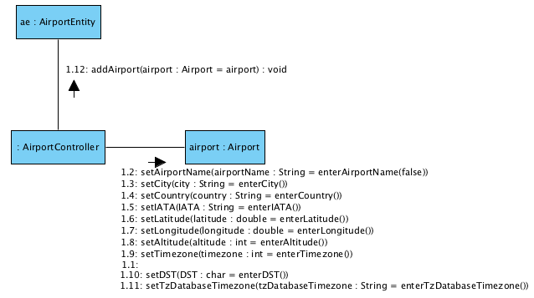

### Add Customers

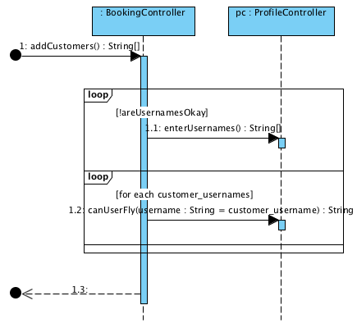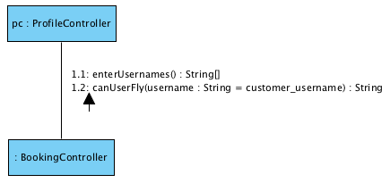

### Add Flight

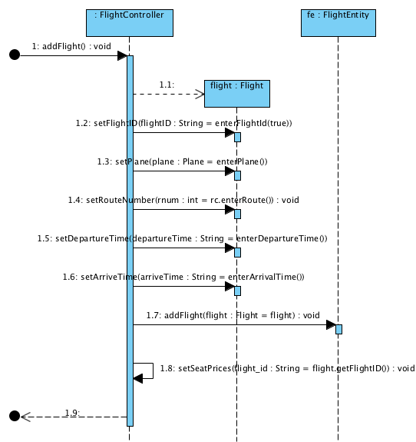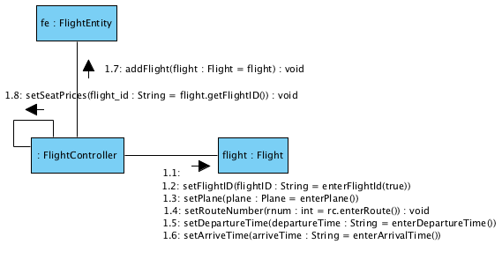

### Add Persons

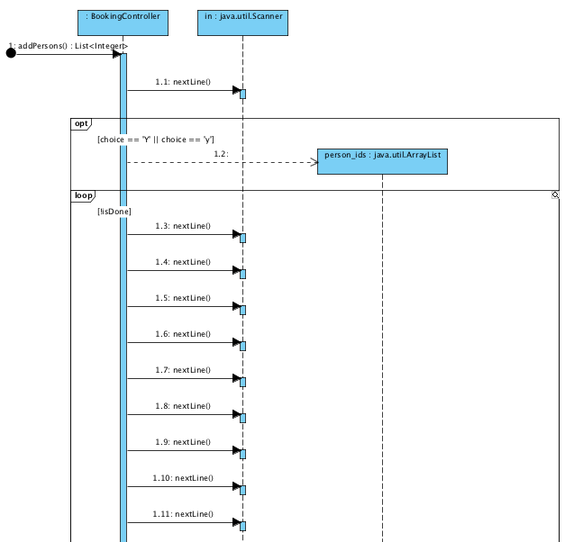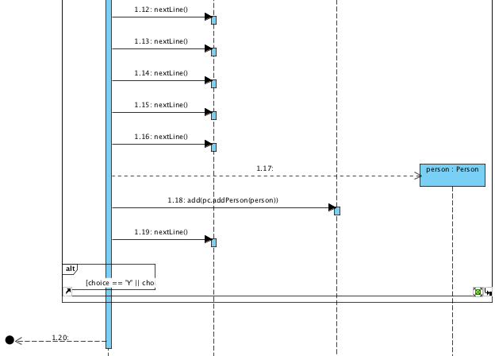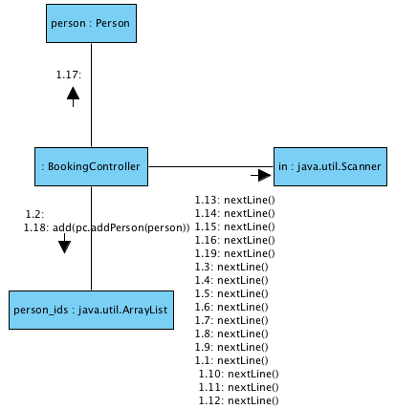

### Add Plane

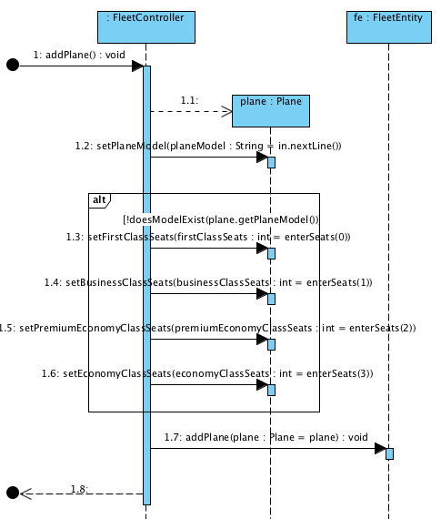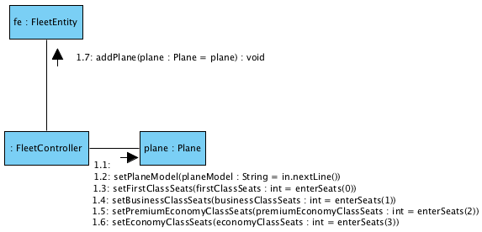

### Add Route

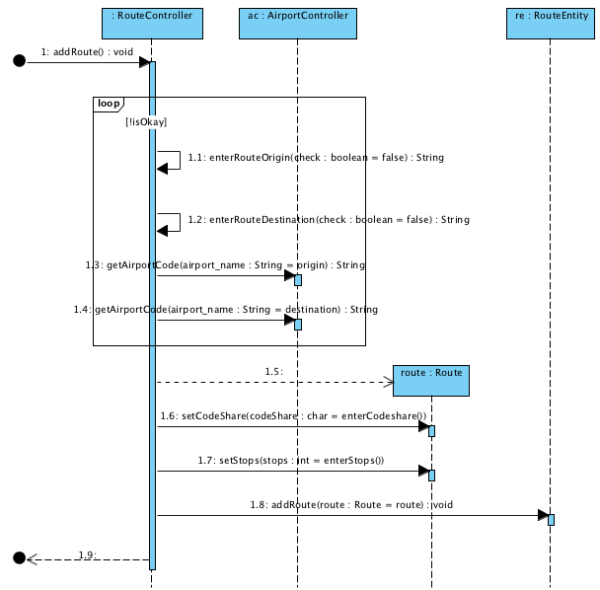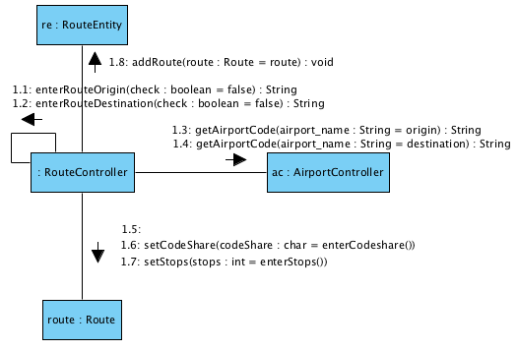

### Add Services

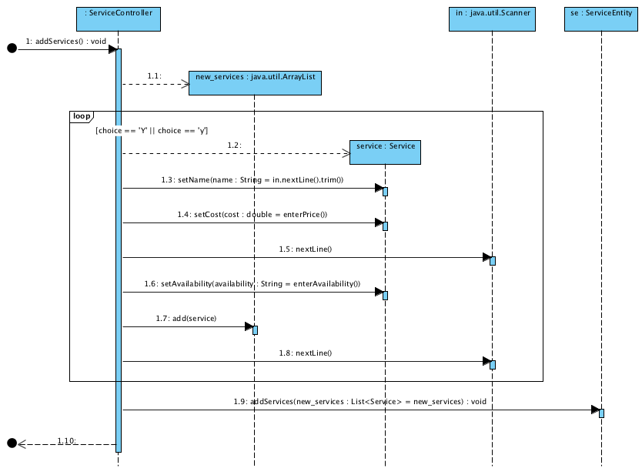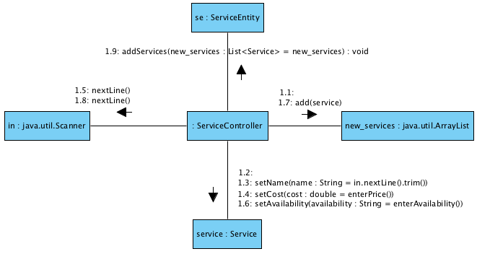

### Book Services

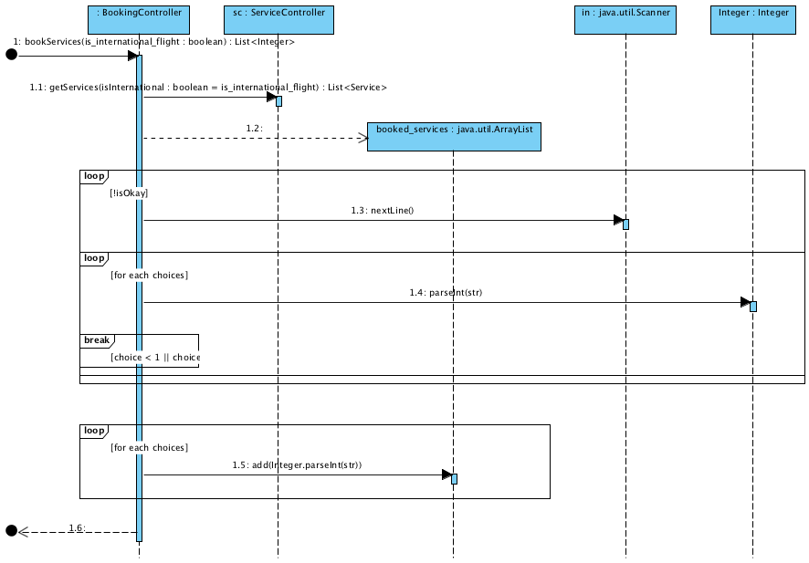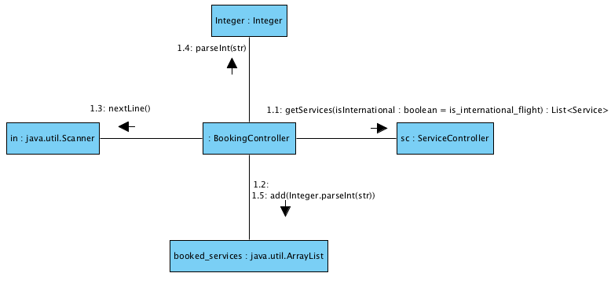

### Cancel Booking

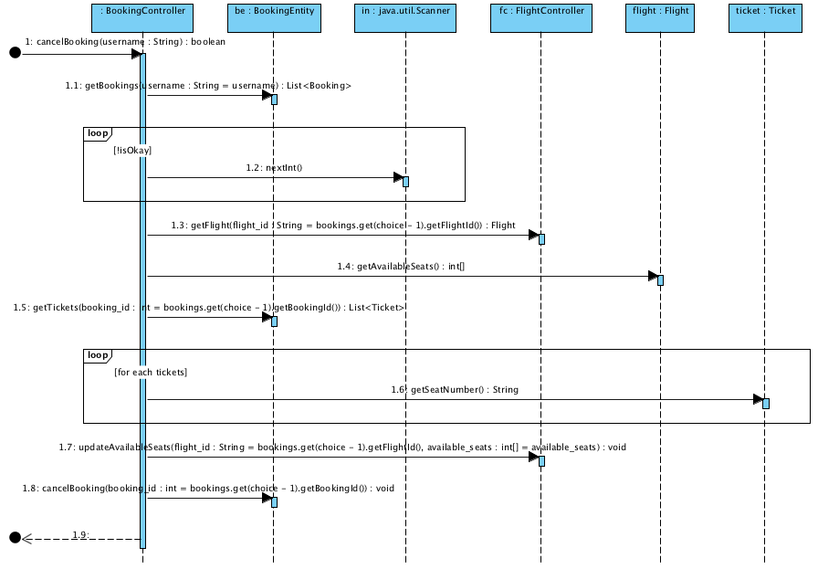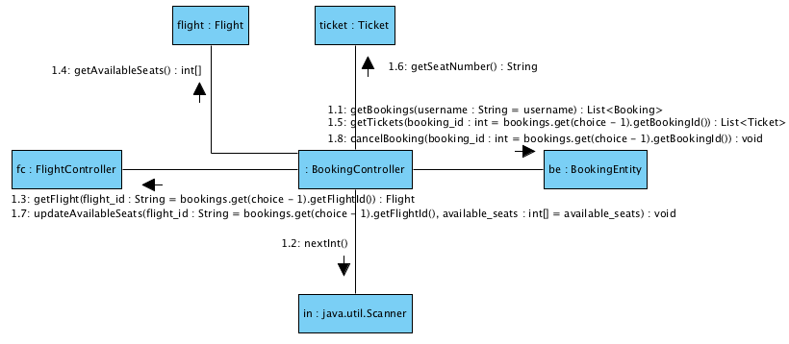

### Change Password

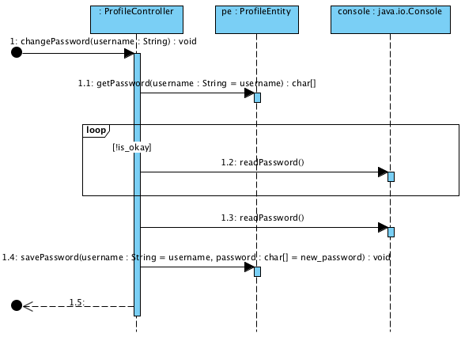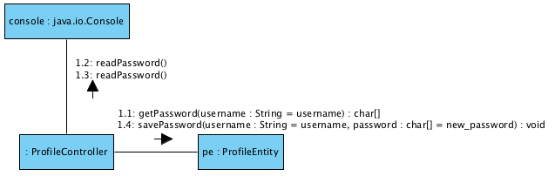

### Choose Seating

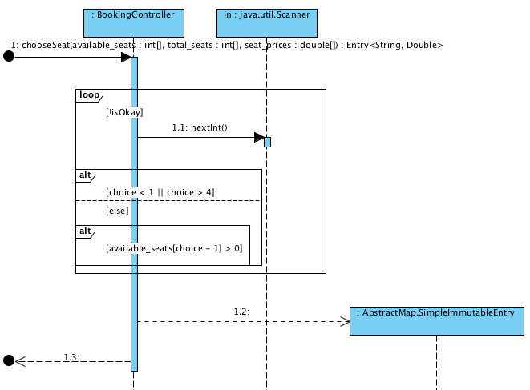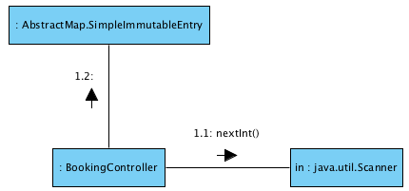

### Close Account

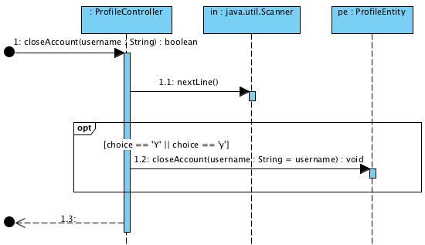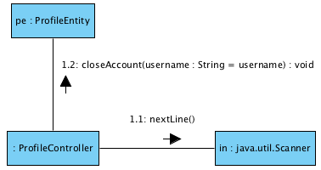

### Create Staff Profile

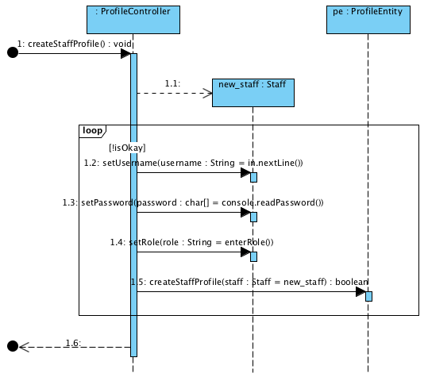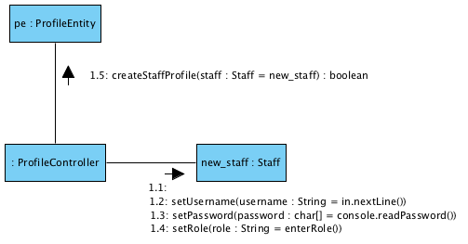

### Delete Airport

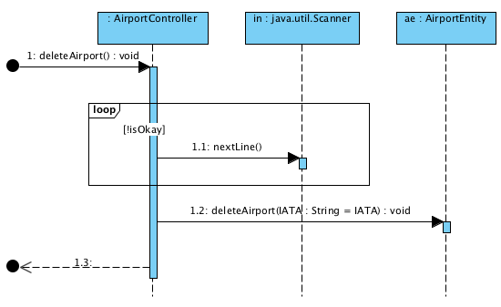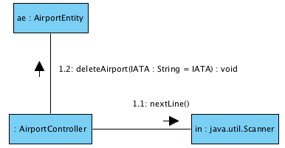

### Delete Flight

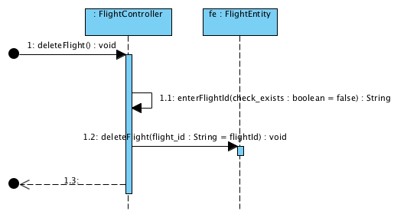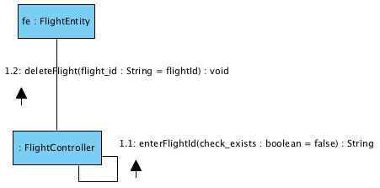

### Delete Plane

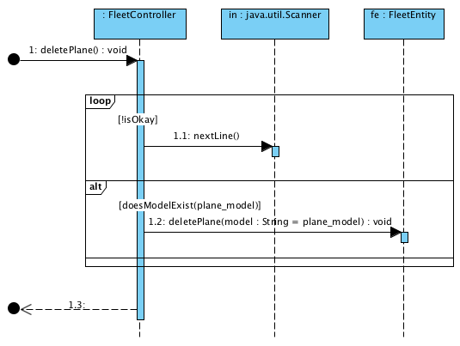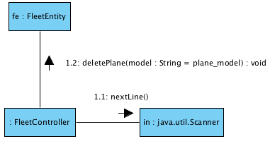

### Delete Route

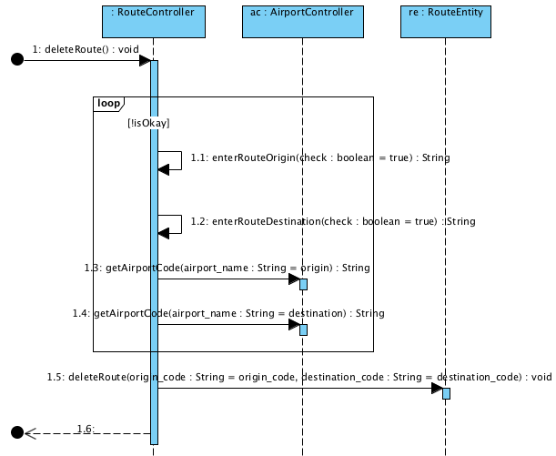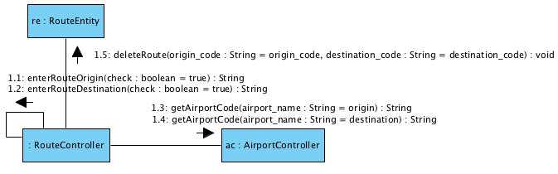

### Display Bookings For Month

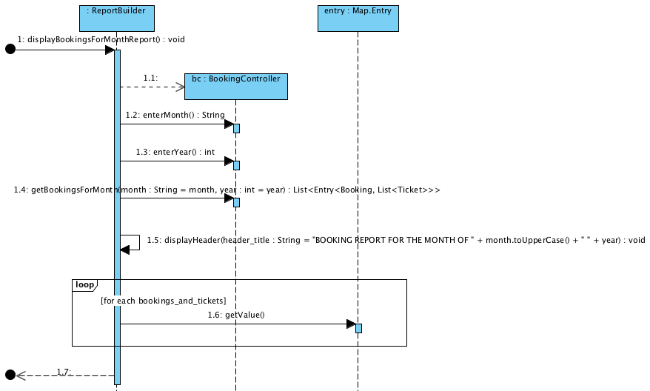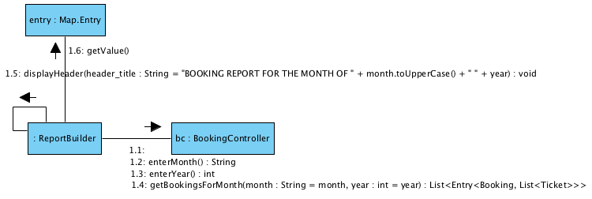

### Display Flight History Report

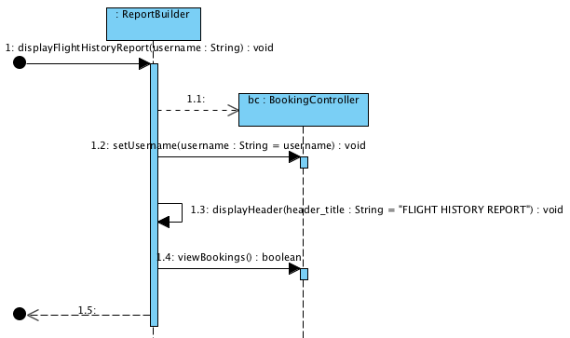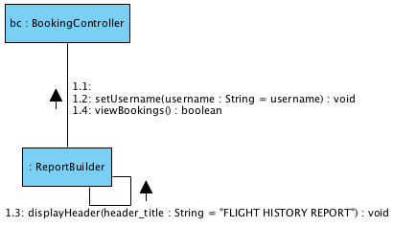

### Display Monthly Flight Statistics Report

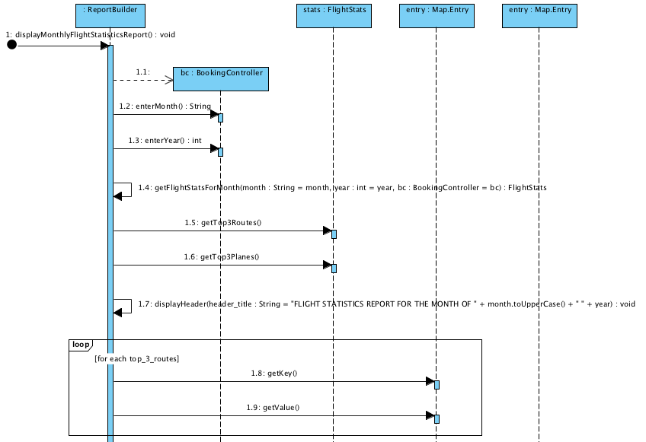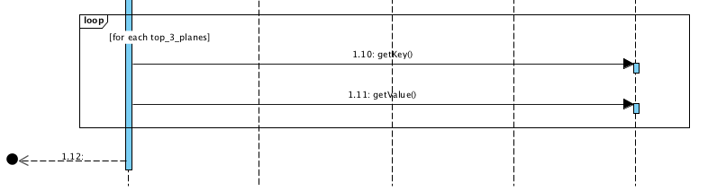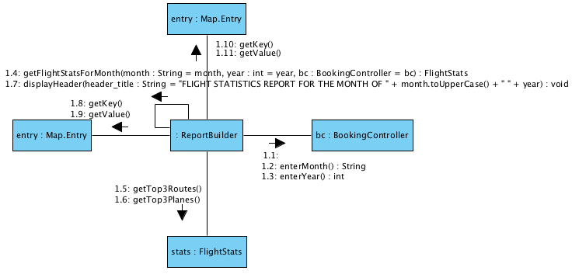

### Display Monthly Revenue Report

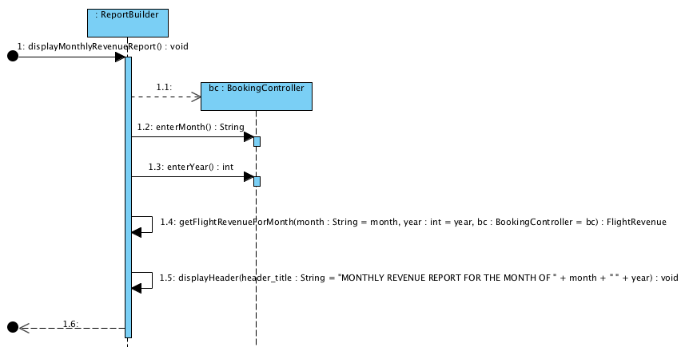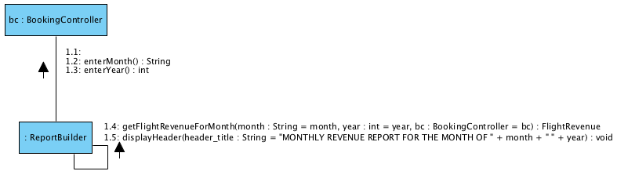

### Display Top 5 Popular Popular Services Report

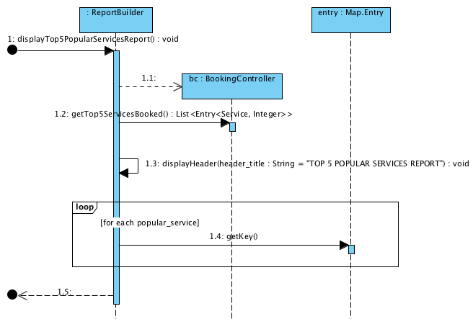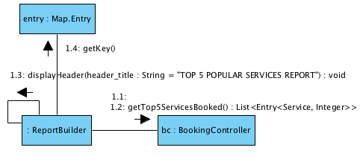

### Edit Account Details

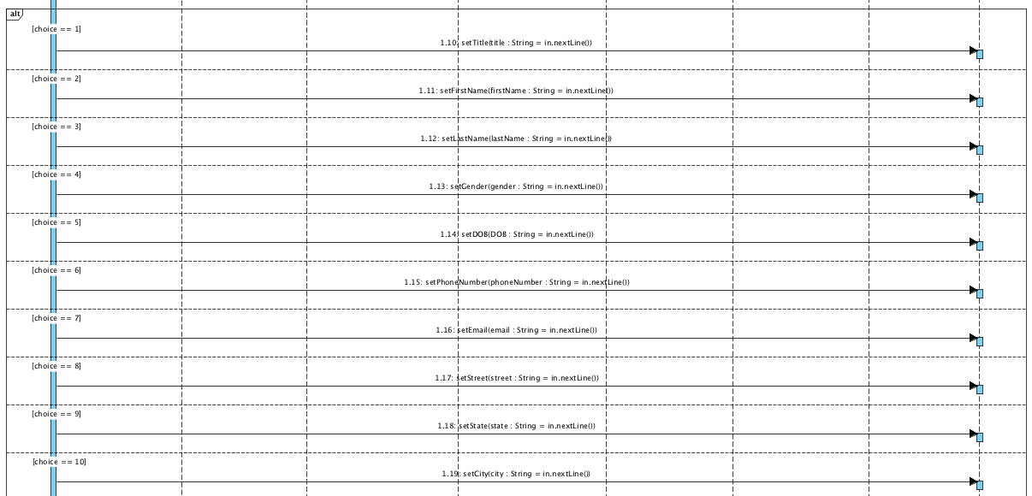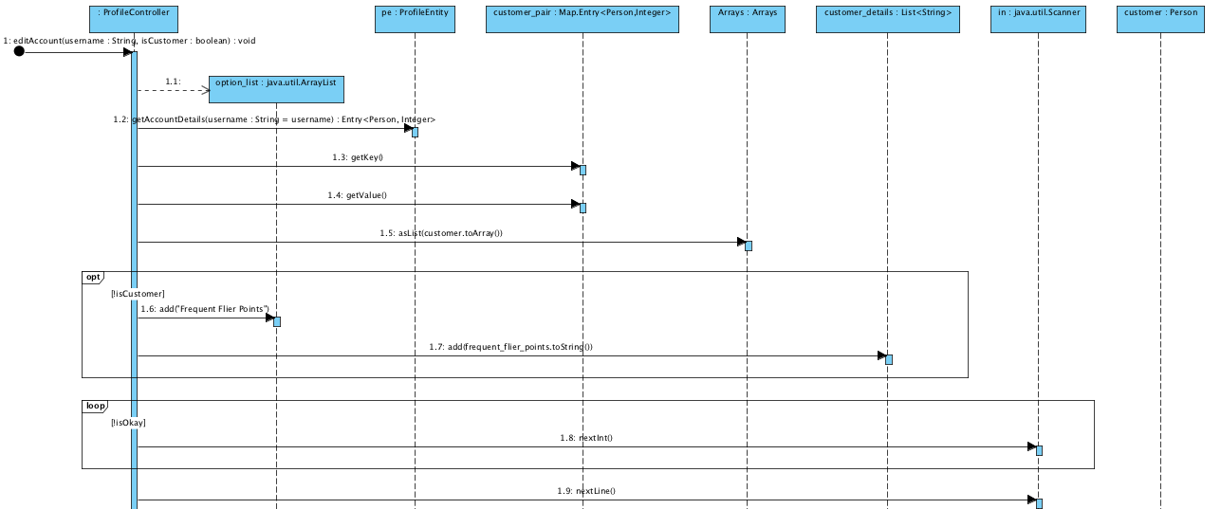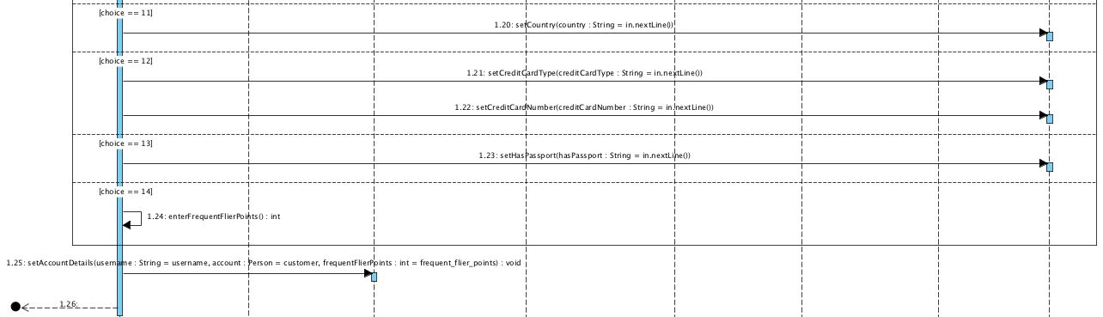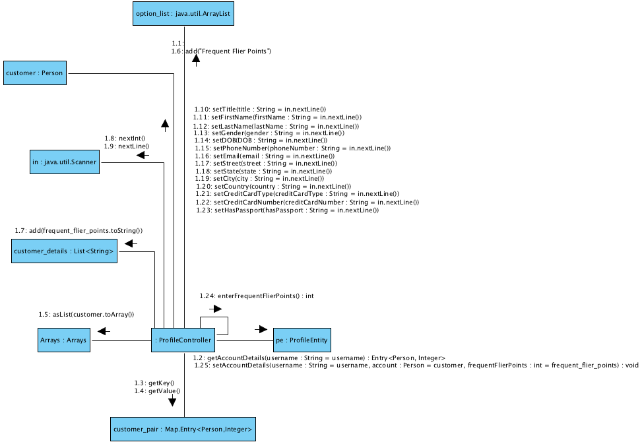

### Edit Airport

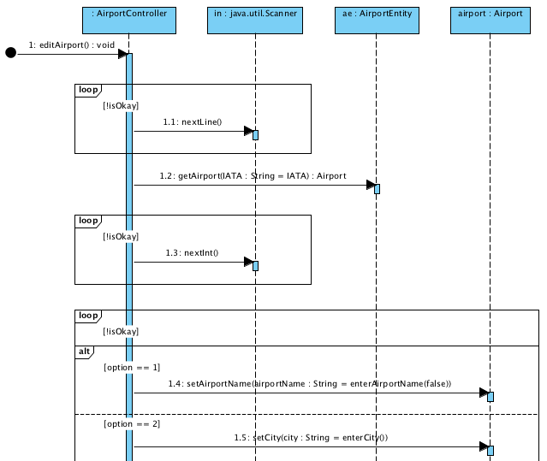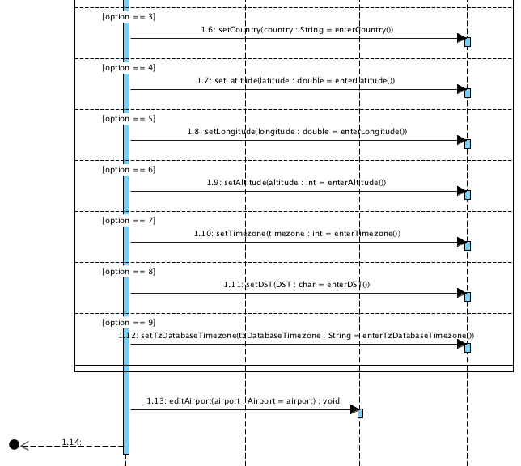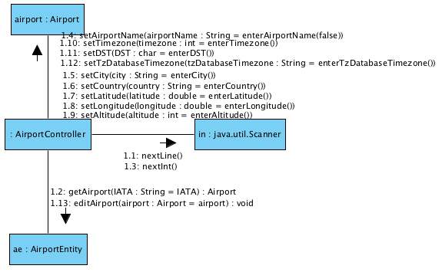

### Edit Booked Services

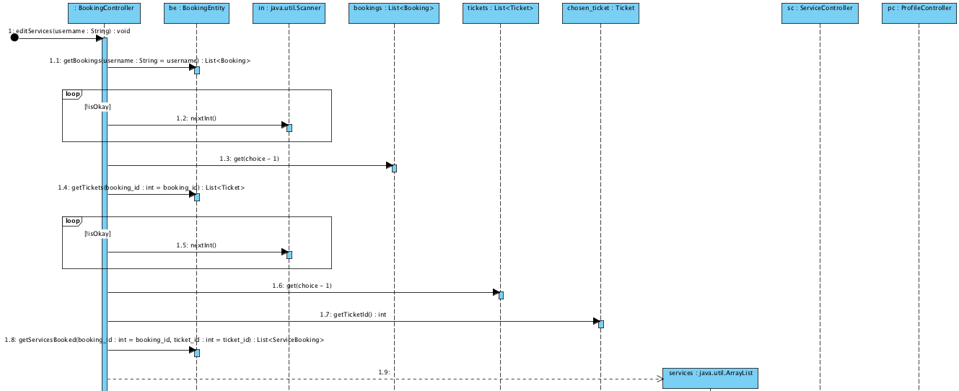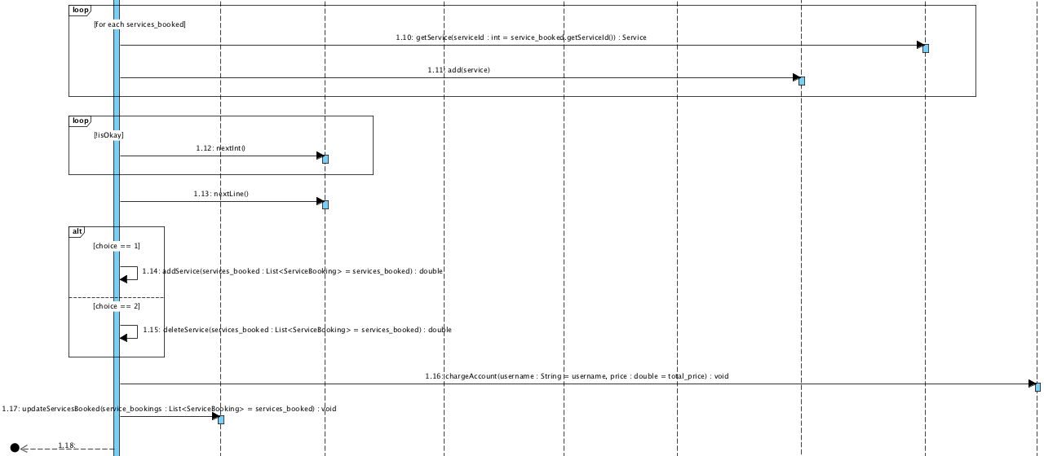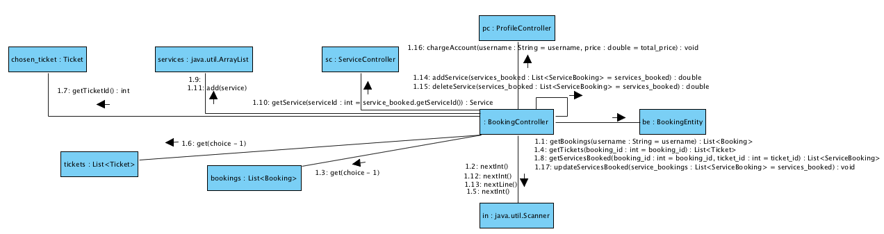

### Edit Flight

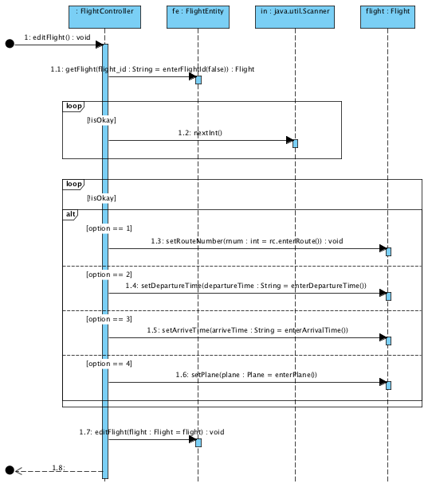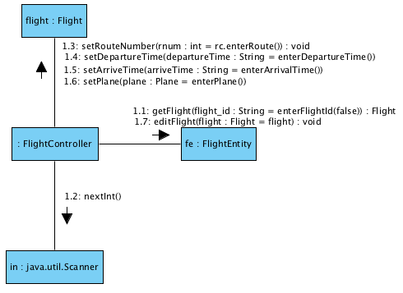

### Edit Plane

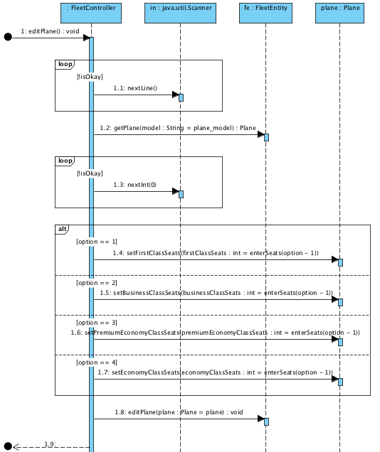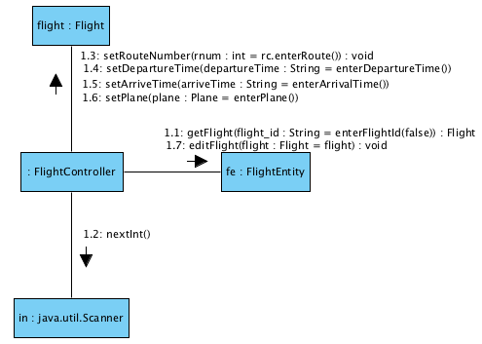

### Edit Route

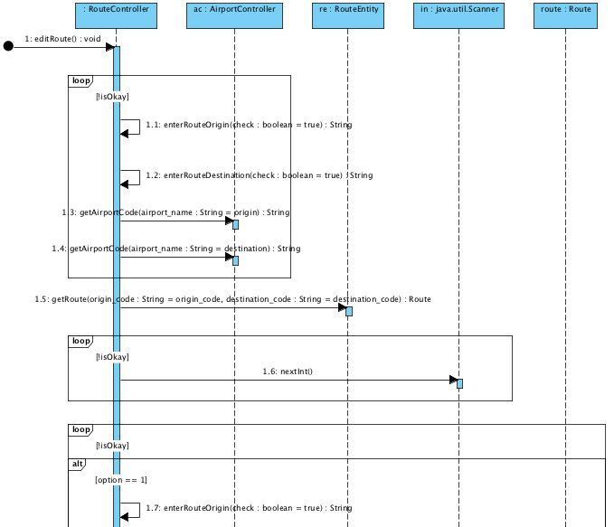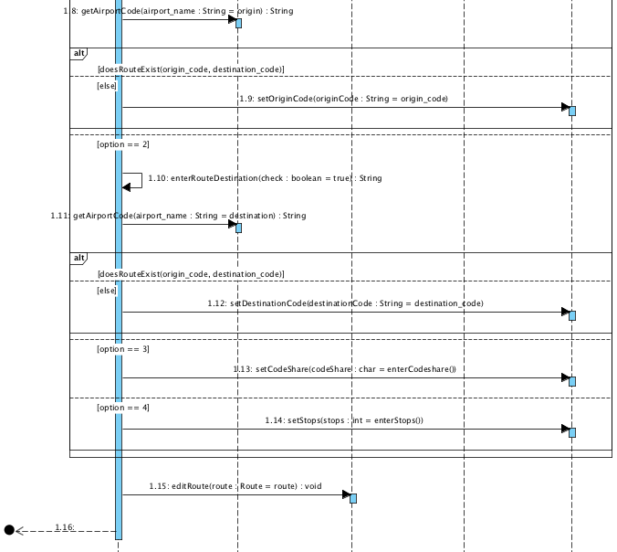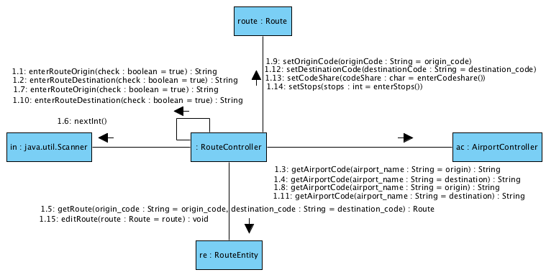

### Edit Service Availability

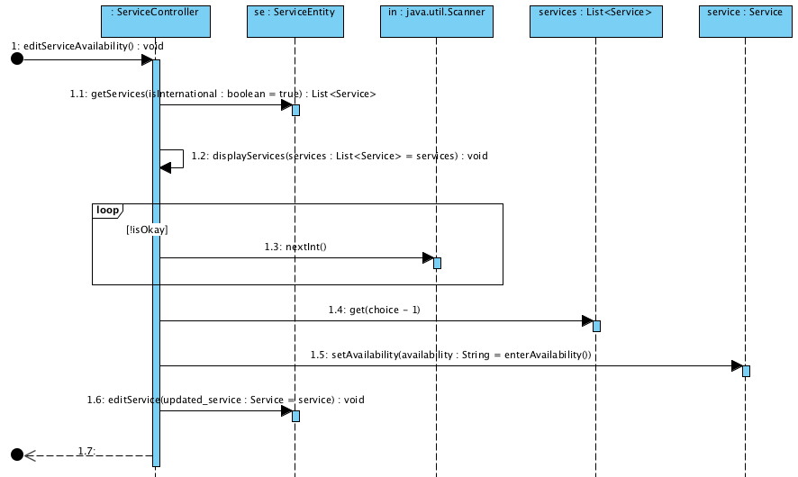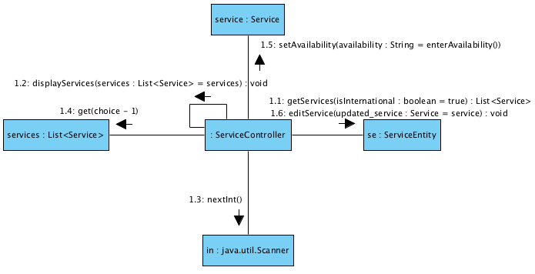

### Edit Service Price

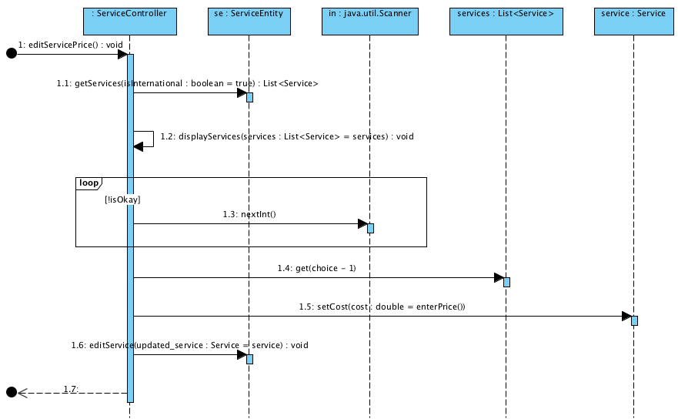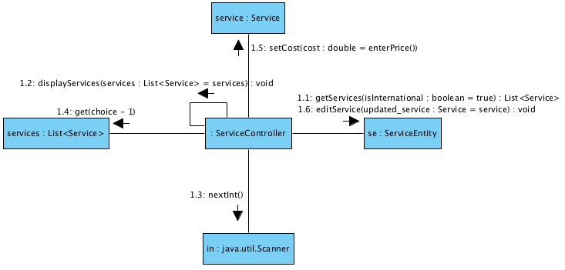

### Edit Staff Profile

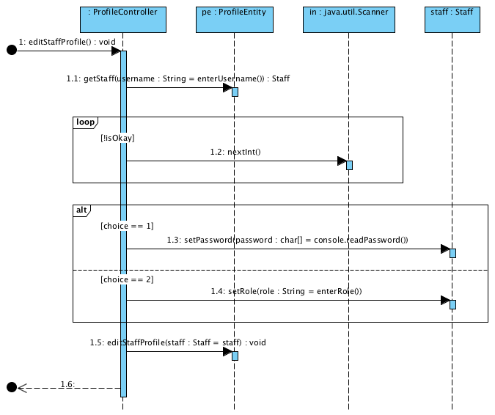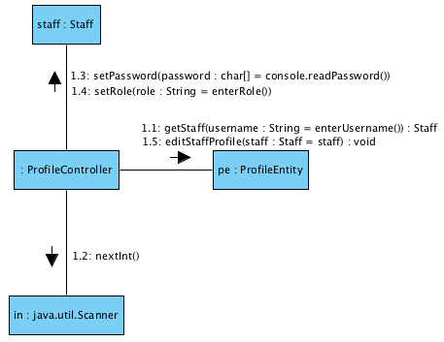

### Edit Watch and No Fly List

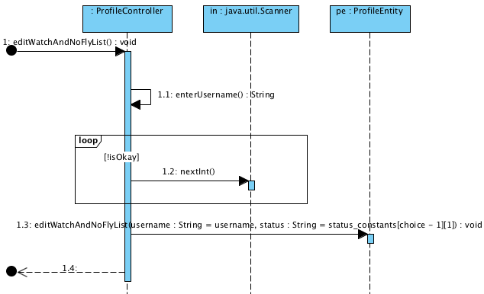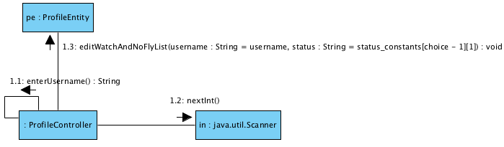

### Login

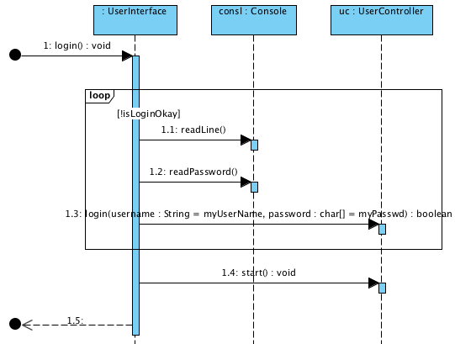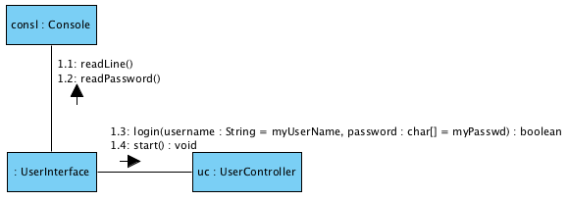

### Make Booking

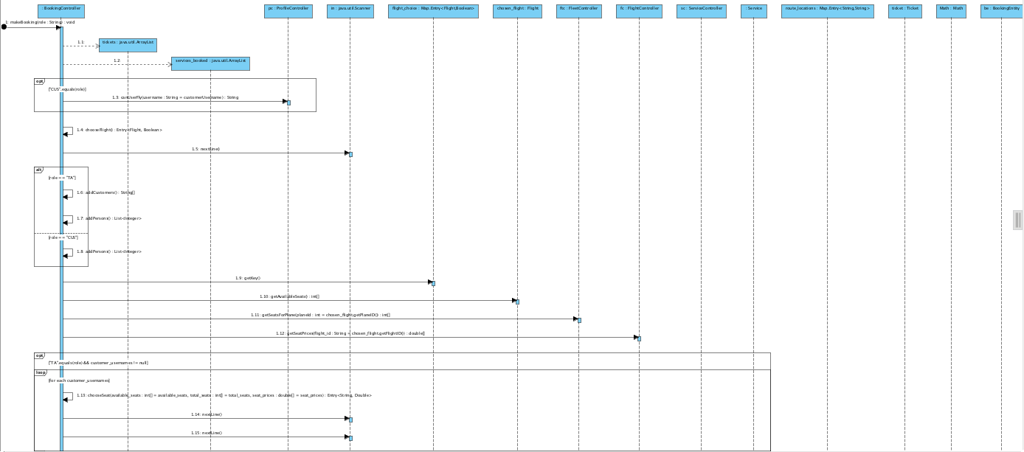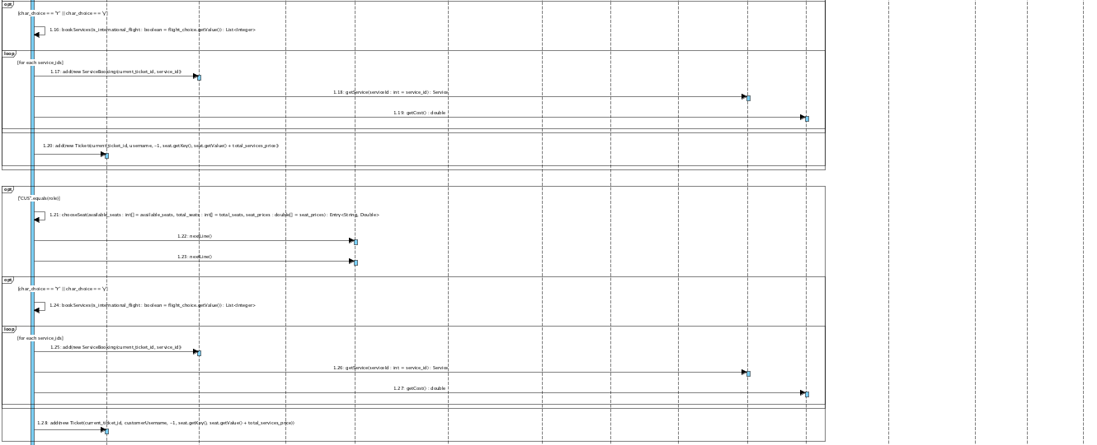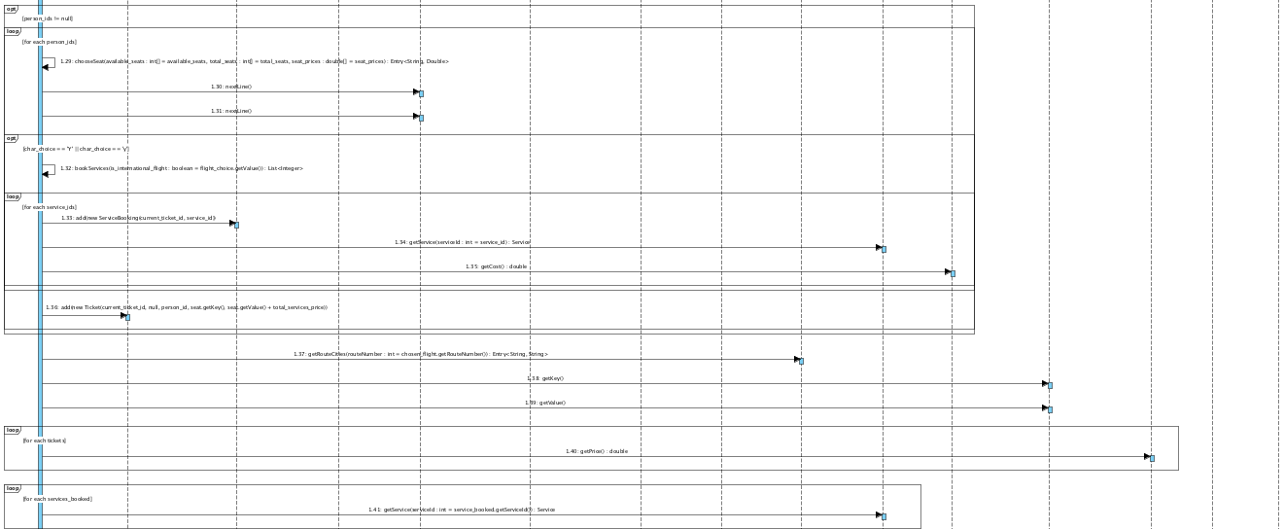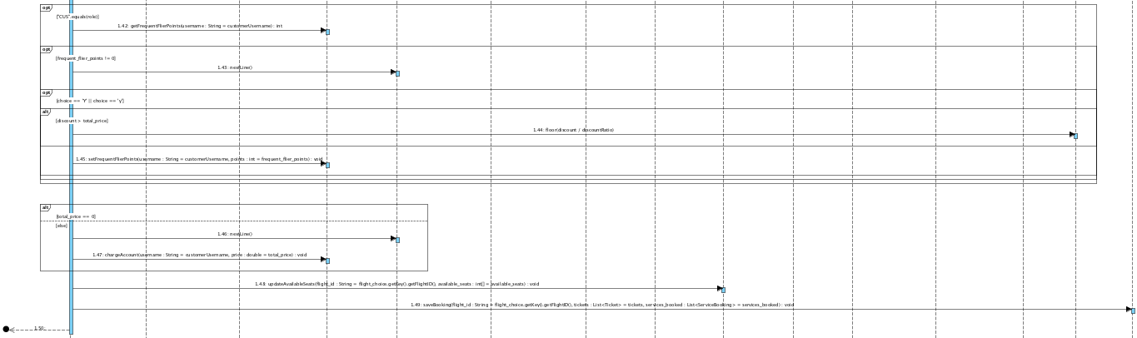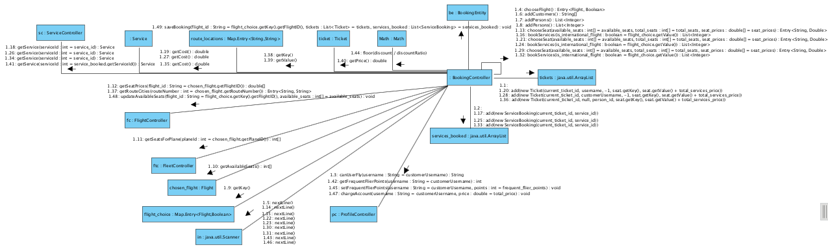

### Manage Airports

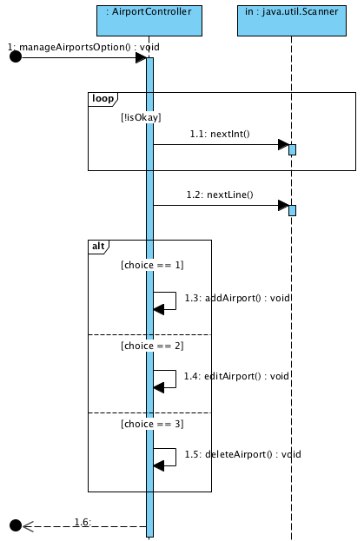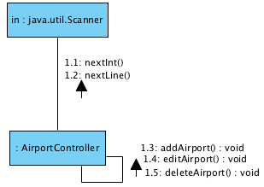

### Manage Fleet

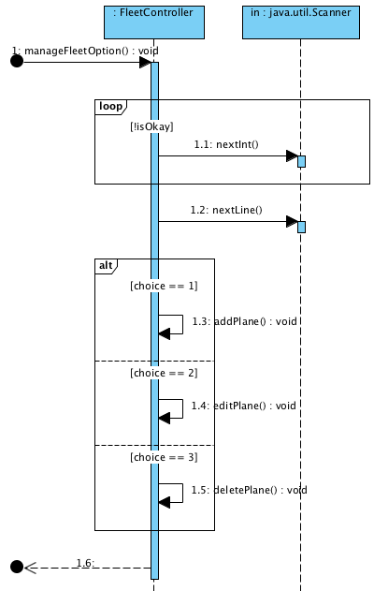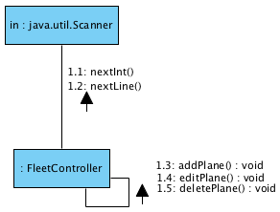

### Manage Flights

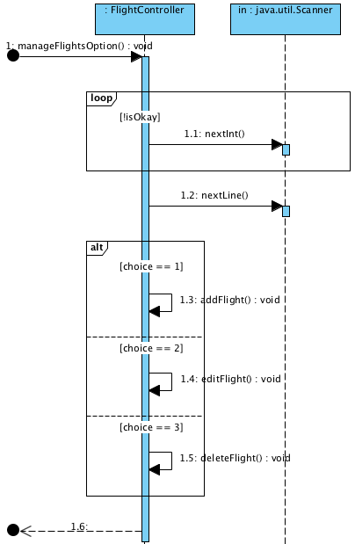

### Manage Routes

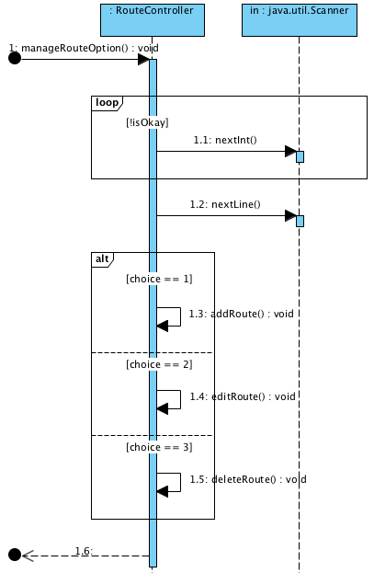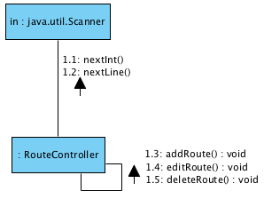

### Move Passengers

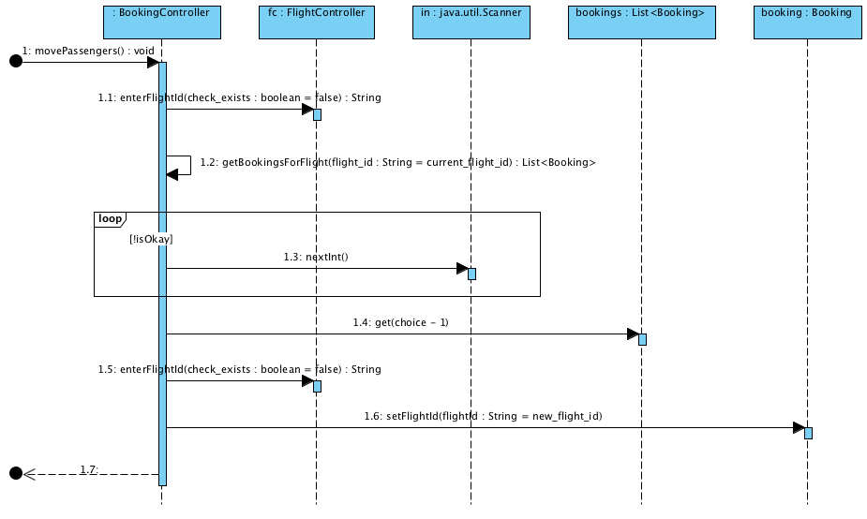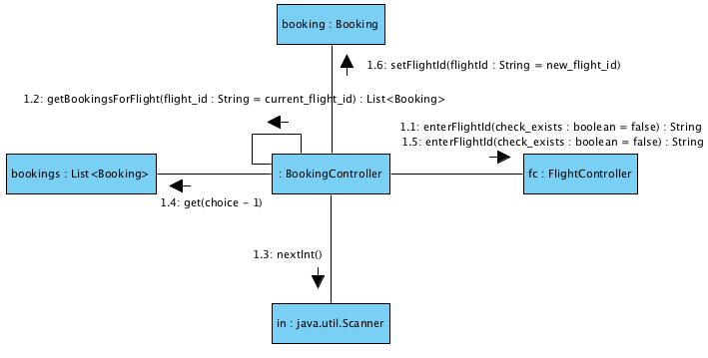

### Remove Services

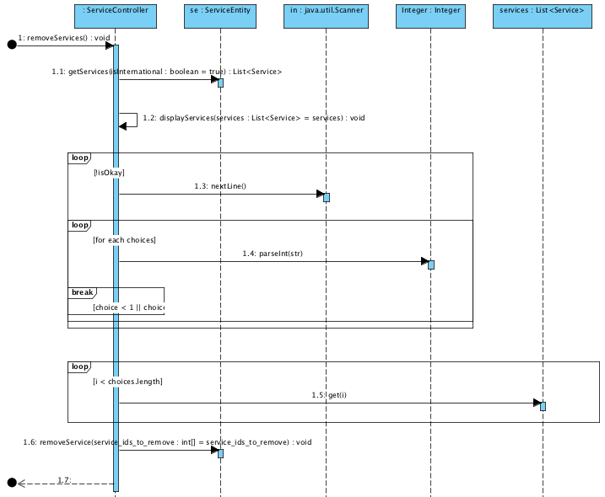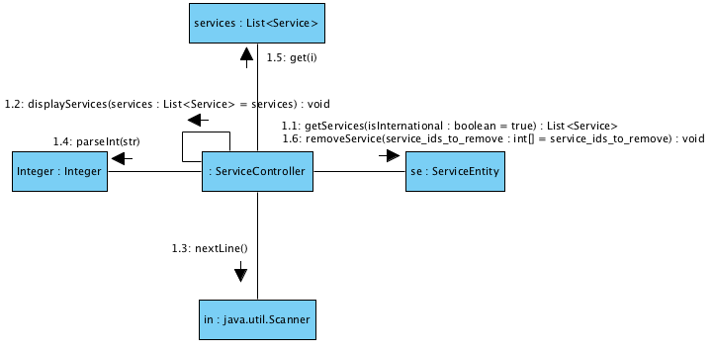

### Set Cancellation Fee

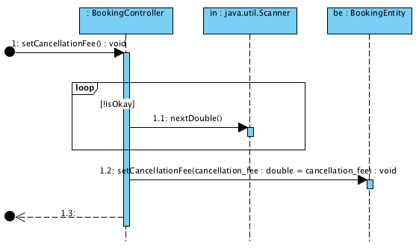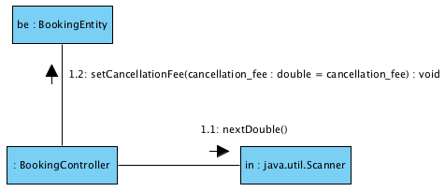

### Set Discount Ratio

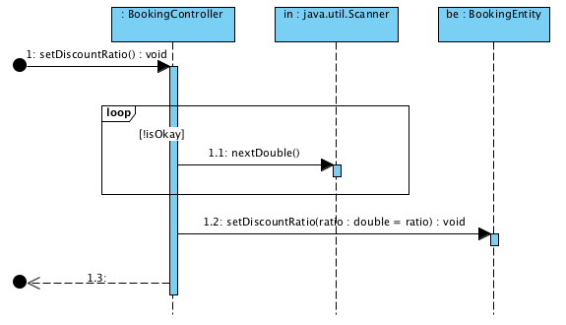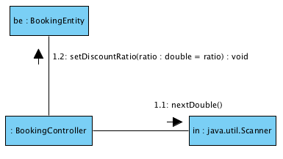

### Set Ticket Price

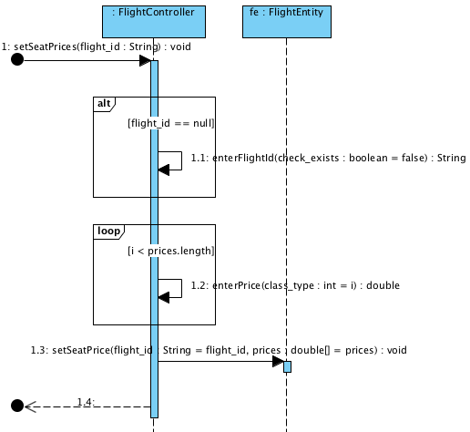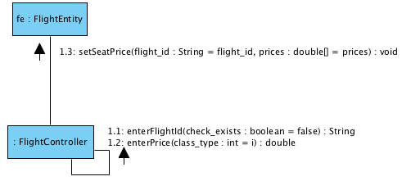

### Signup

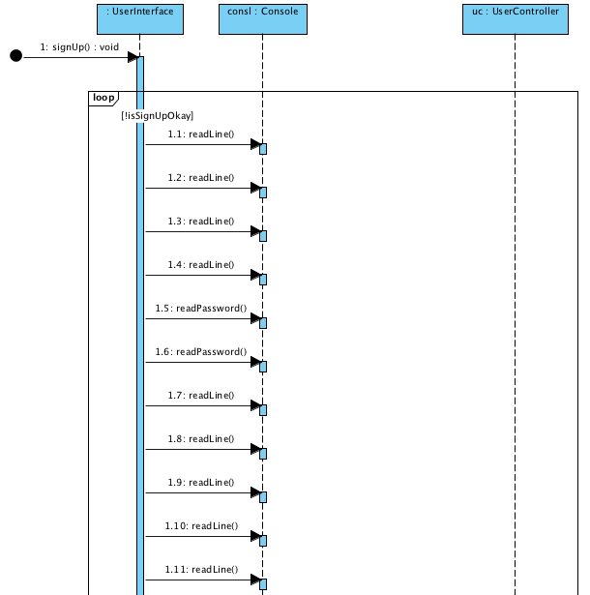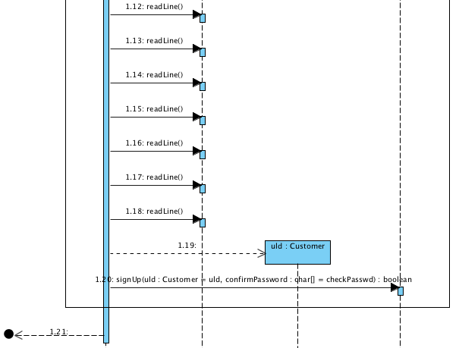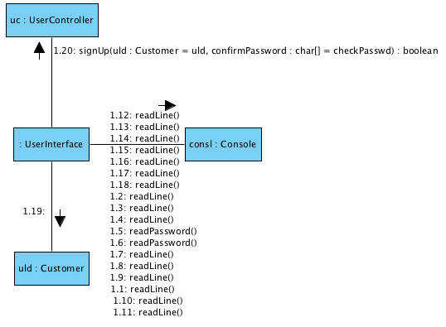

## Activity Diagrams

This section contains all activity diagrams for the proposed Flight Management System. Each diagram’s title is a brief description of the scenario it depicts.

### Add Airport

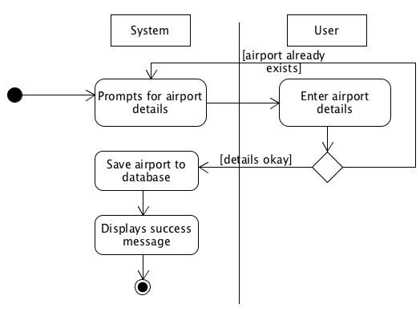

### Add Customers

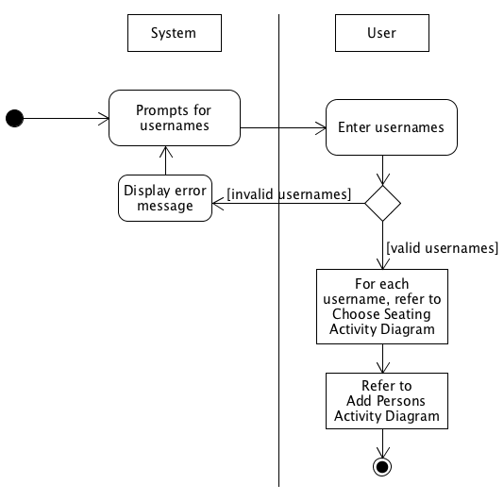

### Add Flight

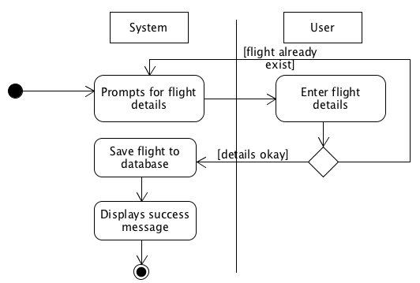

### Add Persons

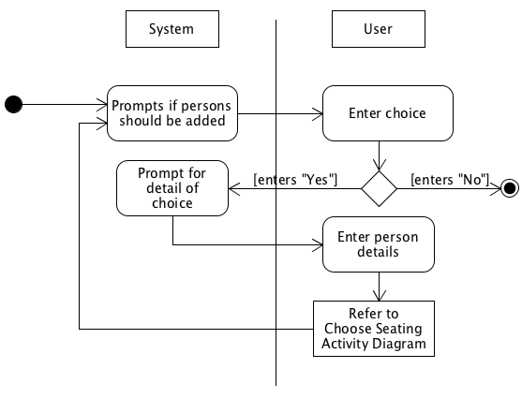

### Add Plane

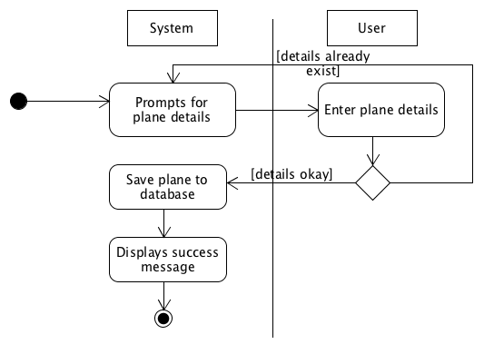

### Add Route

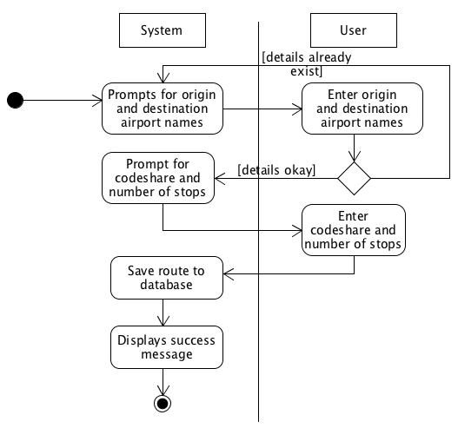

### Add Services

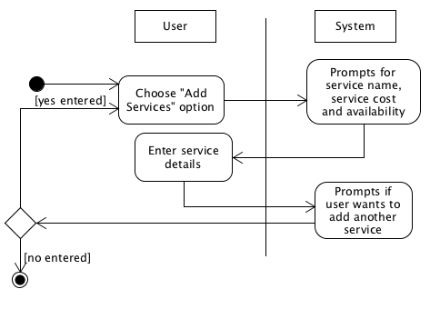

### Book Services

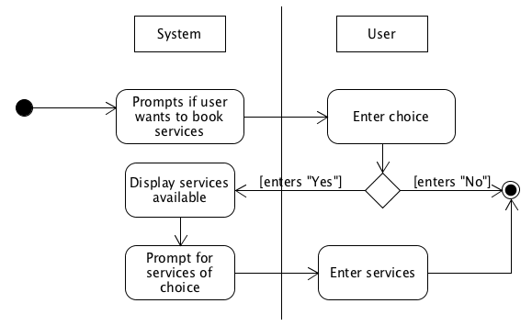

### Cancel Booking

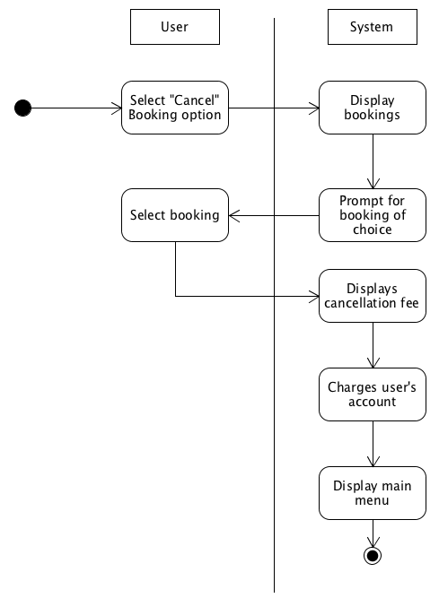

### Cancel Customer Booking

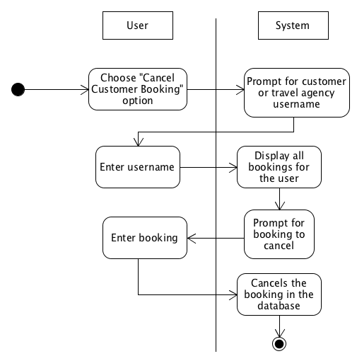

### Change Passenger Seating

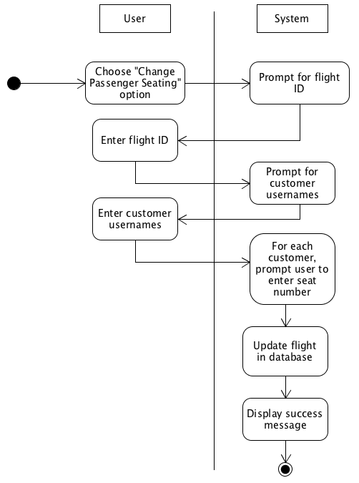

### Change Password

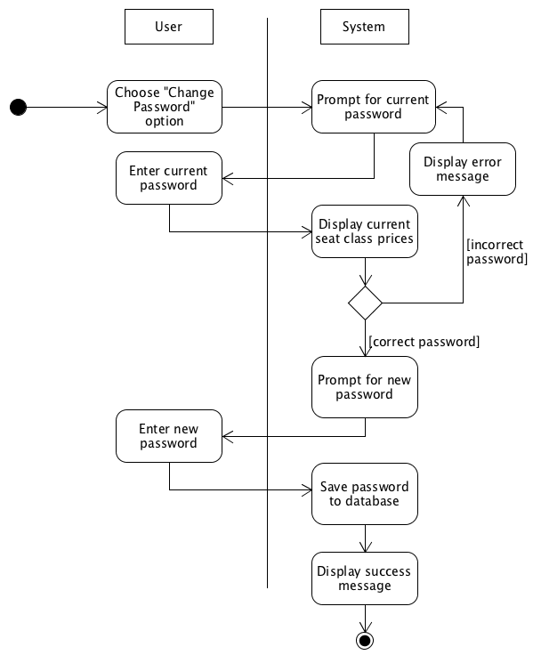

### Choose Seating

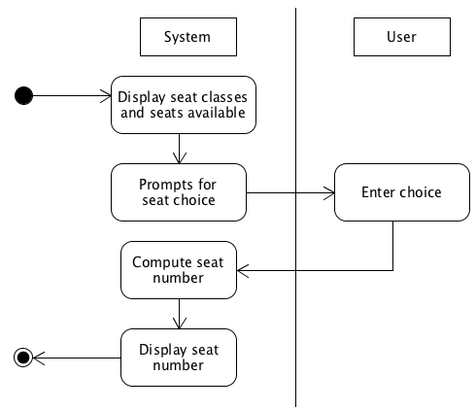

### Close Account

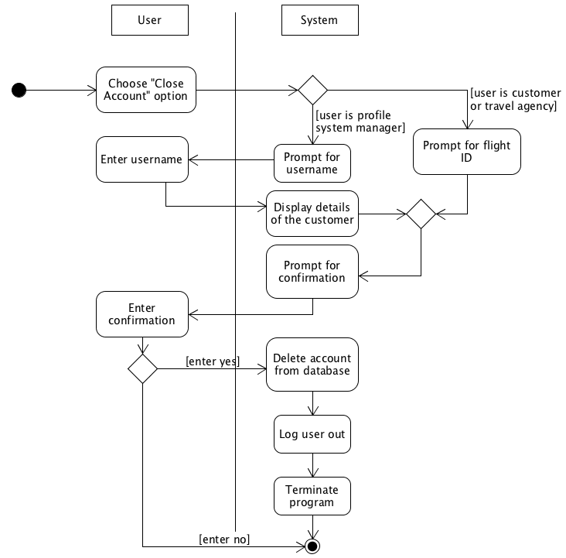

### Create Staff Profile

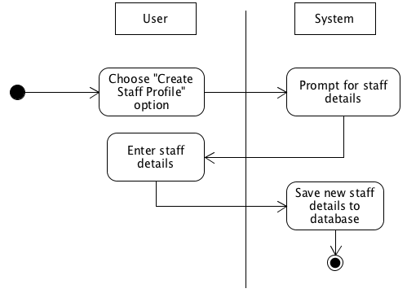

### Delete Airport

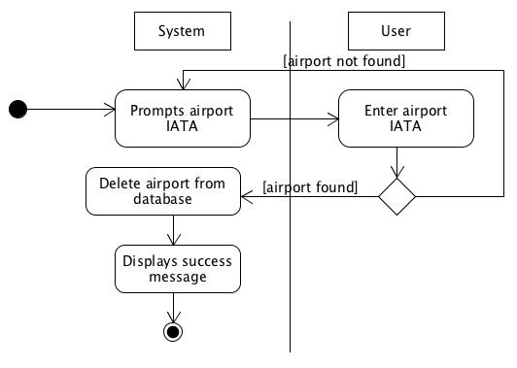

### Delete Flight

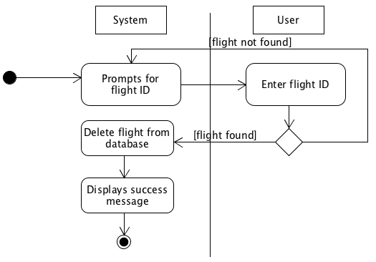

### Delete Plane

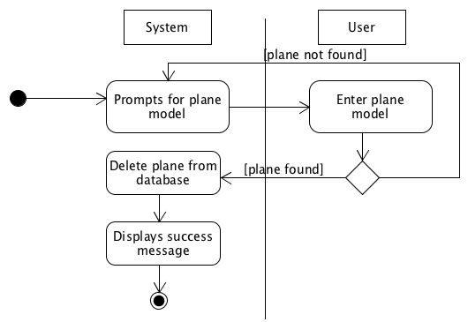

### Delete Route

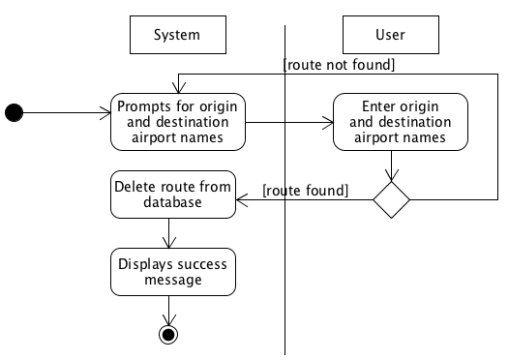

### Edit Account Details

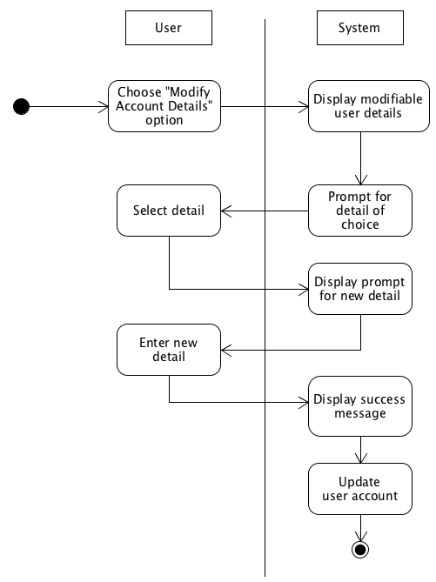

### Edit Airport

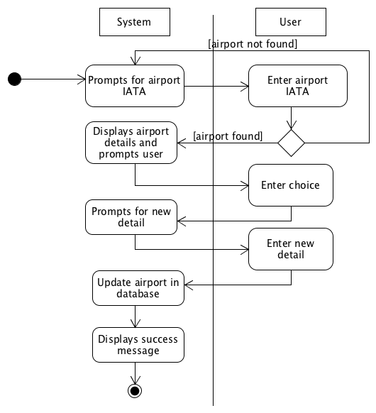

### Edit Flight

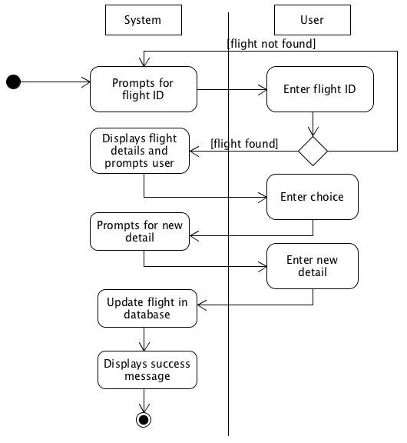

### Edit Plane

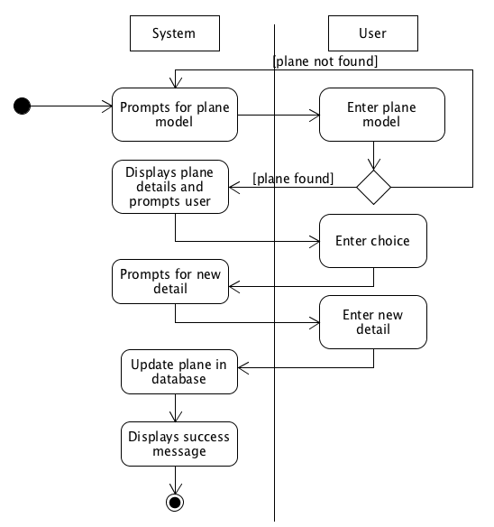

### Edit Route

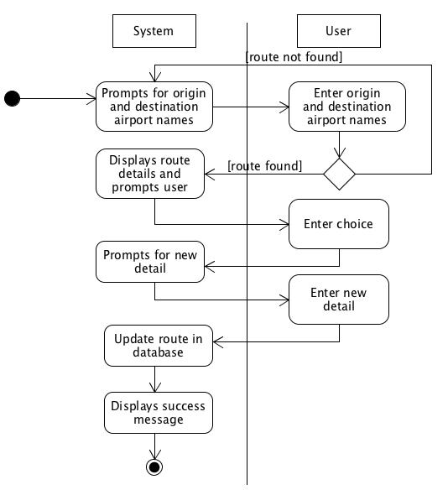

### Edit Service Availability

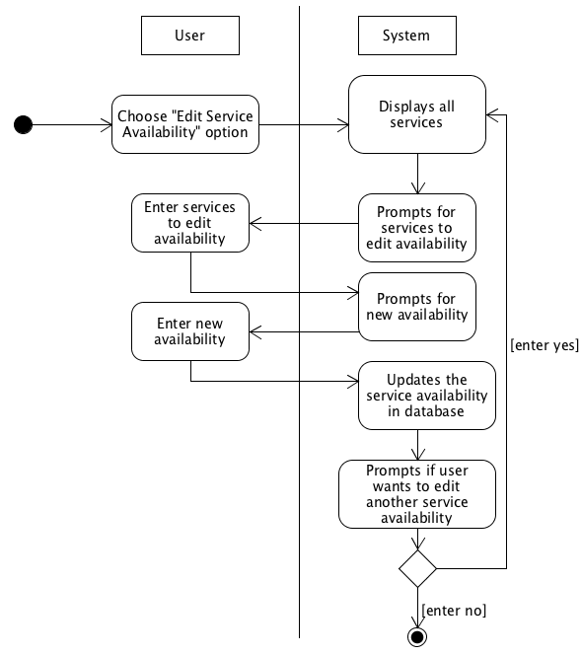

### Edit Service Price

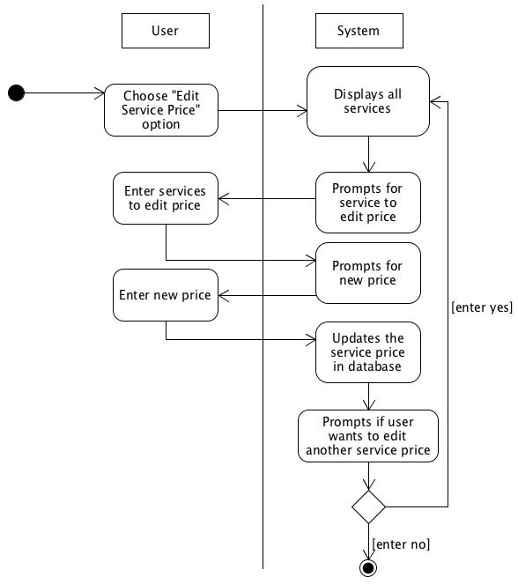

### Edit Services

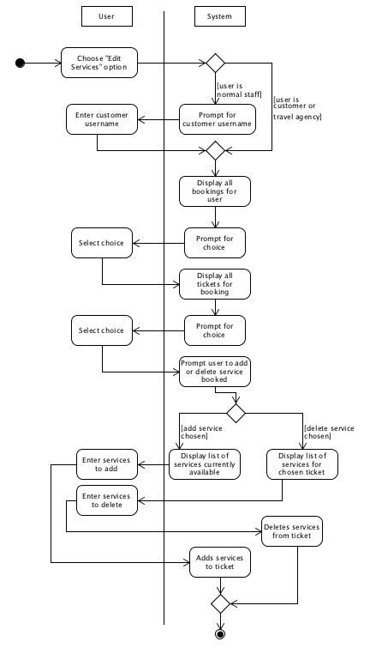

### Edit Staff Profile

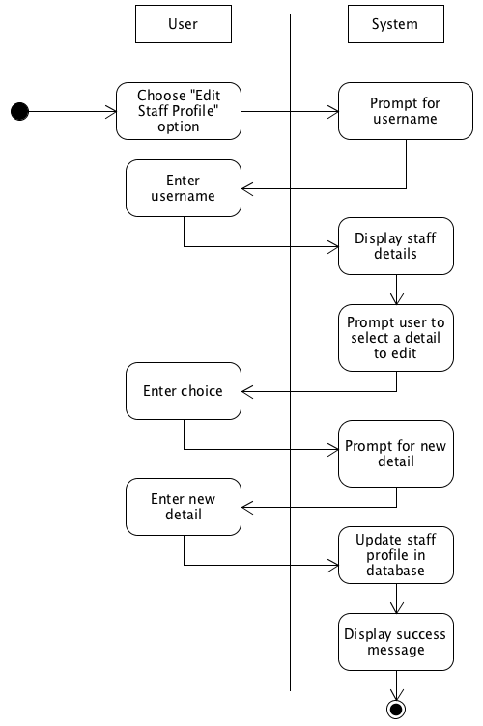

### Edit Travel Agency and Customer Profile

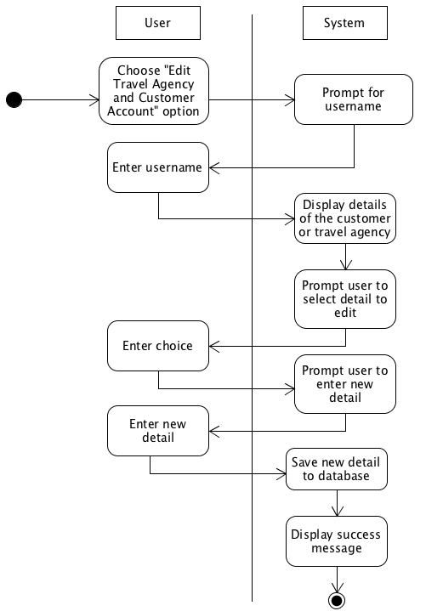

### Edit Watch and No Fly List

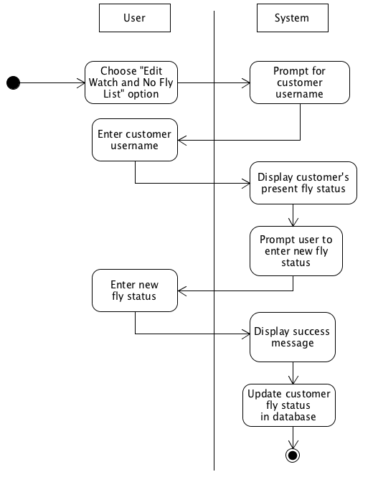

### Generate Report

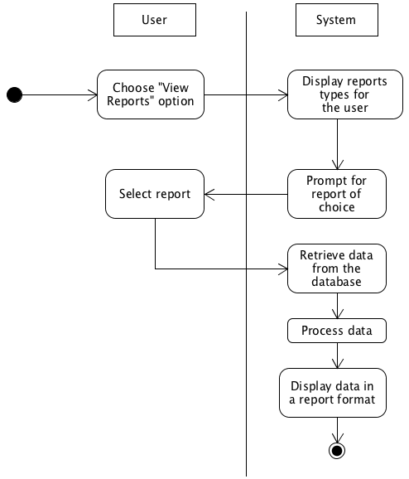

### Login

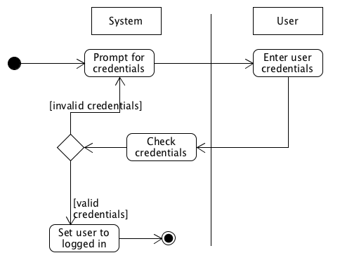

### Make Booking

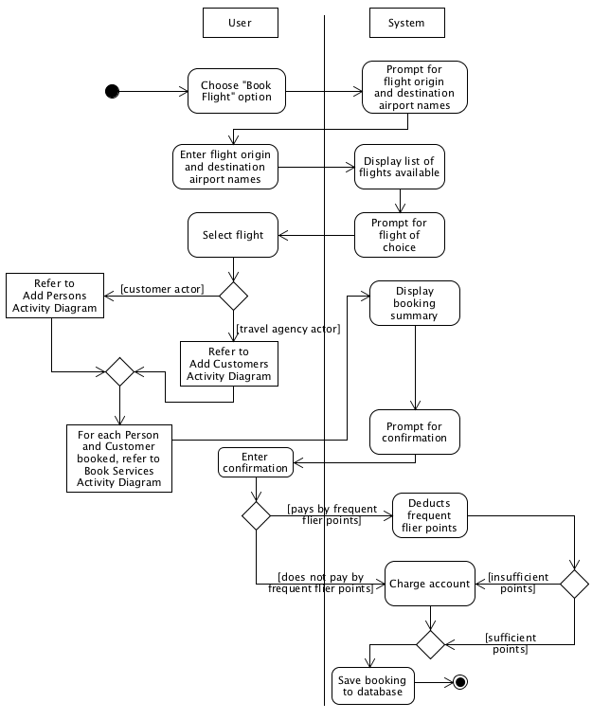

### Manage Airport

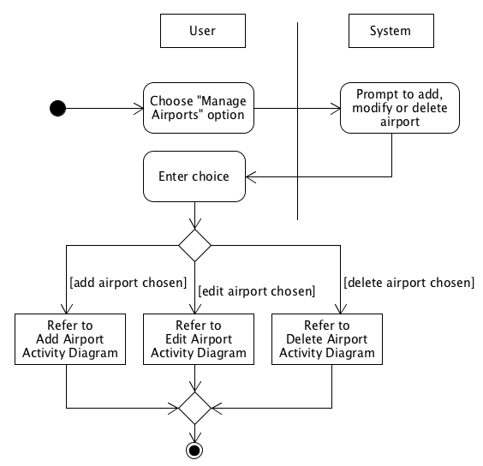

### Manage Fleet

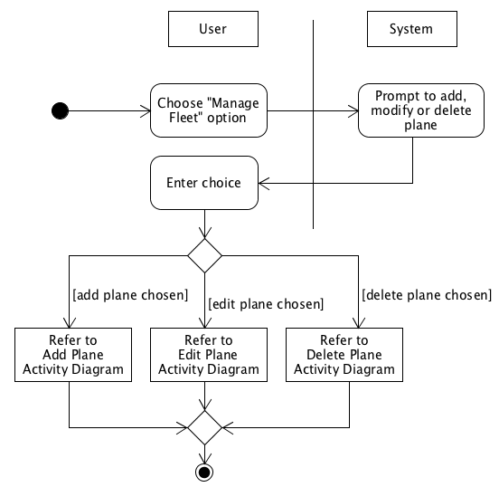

### Manage Flight Schedule

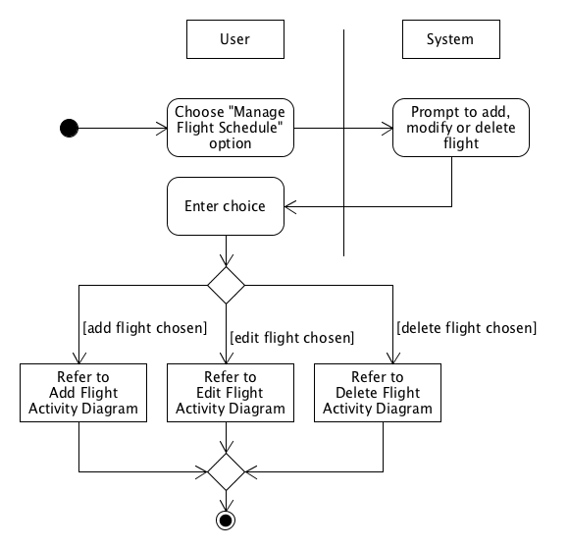

### Manage Routes

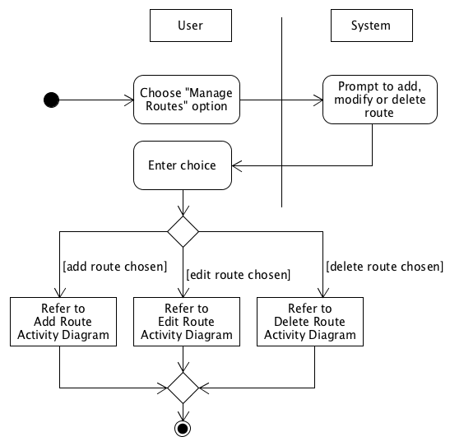

### Move Passengers Between Flights

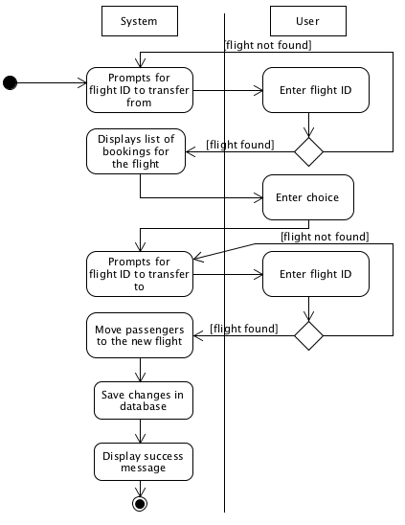

### Remove Services

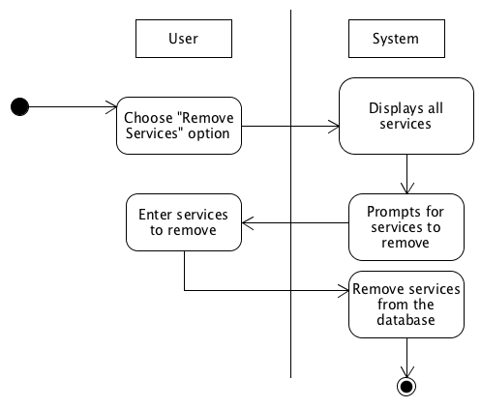

### Set Cancellation Fee

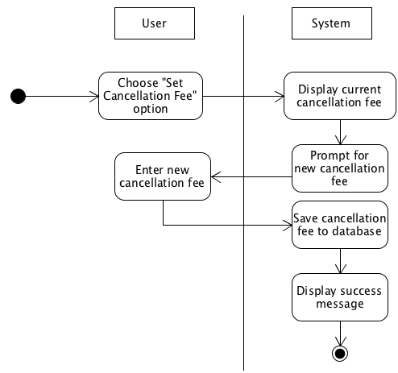

### Set Frequent Points Discount Ratio

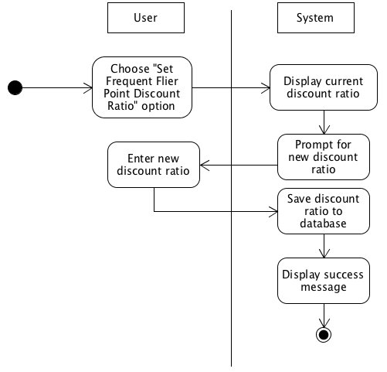

### Set Ticket Prices

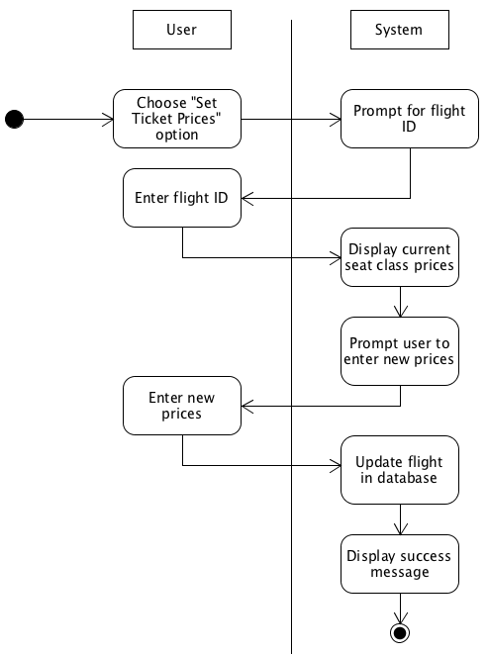

### Signup

